Web Based Precision Agriculture through Crop Recommendation & Disease Detection using AI

Veena Devi
Dept. of ECE
RV College of Engineering Bengaluru, India veenadevi@rvce.edu.in

Shayak Bose
Dept. of ECE
RV College of Engineering Bengaluru, India shayakbose.ec21@rvce.edu.in

Abstract—Agriculture in India is confronted with significant obstacles, including suboptimal crop and fertilizer selection, which lead to reduced yields and economic losses for farmers. To address these challenges, this project introduces an integrated intelligent farming platform delivering crop recommendation, fertilizer suggestion, and disease detection services. The crop recommendation module, based on a majority voting ensemble of Random Forest, Decision Tree, SVM, and Logistic Regression, achieved accuracies of 90%, 94.3%, 97%, and 99% respectively, with Random Forest emerging as the most effective model. The fertilizer recommendation engine uses a rule-based approach to match soil nutrient data with crop-specific requirements, provid- ing precise nutrient correction suggestions. The disease detection module, powered by a ResNet-9 CNN, offers rapid and accurate classification of plant leaf diseases, delivering both preventive and curative recommendations; for instance, it successfully identified Cedar Apple Rust in test images with high confidence. By synthesizing these modules, the platform demonstrated real-time capability, high accuracy, and practical usability, offering farmers actionable insights to enhance productivity, sustainability, and profitability.
Index Terms—Precision agriculture, Recommendation system, Random Forest, Support Vector Machine (SVM), Logistic Re- gression, Deep Learning, Artificial Intelligence.

- Introduction
Farming is essential for both food supply and economic health worldwide. Yet, many conventional farming methods depend on personal judgment, which may not always result in the best use of resources or optimal crop output. The emergence of machine learning and deep learning has paved the way for precision agriculture, offering data-driven insights that can significantly improve farming outcomes. With the advent of Machine Learning (ML) and Deep Learning (DL), precision agriculture has emerged as a transformative solution that leverages data-driven insights to enhance farming effi- ciency[1].
Agriculture is vital to many economies, especially in India, where over Nearly seven out of every ten people earn their living through farming activities. However, challenges like poor crop selection, inefficient fertilizer use, and undetected diseases lead to low yields and financial losses. To address these issues, an intelligent system using Machine Learning (ML) has been developed to provide farmers with accurate, data-driven insights[2].
The proposed system offers three key features: crop recom- mendations, fertilizer suggestions, and disease detection [16]. By analyzing soil properties and environmental factors, ML models suggest the best crops and fertilizers[3]. Additionally, an image-based deep learning model detects crop diseases and recommends preventive measures, helping farmers take timely action [17].
What sets the project apart is its high accuracy and real- time capabilities. The Random Forest model achieves 97% accuracy, ensuring reliable recommendations. This integration of technology moves beyond traditional farming, enabling informed and effective decisions[4].
The model is trained using a variety of factors, including en- vironmental variables such as rainfall, humidity, temperature, soil pH, nutrient content, soil classification, and geographic location. It also incorporates economic indicators like produc- tion levels, crop yield, soil salinity, wind patterns, availability of labor, access to credit and financial resources, irrigation infrastructure, pest and disease incidence, elevation, and solar exposure[5].
Precision agriculture refers to an advanced approach to farming that leverages detailed research on soil properties, classifications, and crop yield records. This innovative field is evolving quickly, with the goal of tackling present-day chal- lenges related to sustainable agricultural practices[6]. Machine learning serves as a foundational technology for precision agriculture, driving the creation of sophisticated systems for identifying and categorizing plant diseases. This project offers an overview of how both machine learning and deep learning approaches are utilized within precision agriculture, with a particular focus on the detection and classification of plant diseases[7].
The following Figure 1 illustrates the workflow of data collection, preprocessing, model training, evaluation, and pre- diction in an AI-based agricultural system.
- Data Collection: The system collects information on both soil and environmental conditions, such as levels of nitrogen, phosphorus, and potassium, as well as mea- surements of temperature, humidity, soil pH, and rainfall.
- Data Preprocessing: The data is divided into separate sets for training and testing purposes.

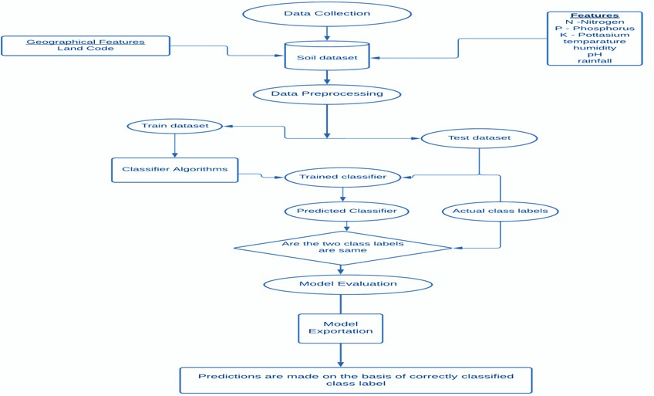
Fig. 1: Flowchart of AI-based Precision Agriculture

- Model Training: Machine learning classifiers are trained using the training dataset.
- Prediction and Evaluation: The trained classifier gener- ates predictions, which are compared against actual class labels.
- Model Exportation: After evaluation, the final model is saved for making accurate predictions.
[8]This workflow enables AI-based precision agriculture, optimizing crop recommendation and disease detection.
Farmers face challenges such as selecting crops based on intuition or market trends rather than soil and environmental conditions, leading to poor yields and financial losses, while
limited knowledge of soil nutrient levels results in improper fertilizer use that adversely impacts crop health and produc- tivity[9], and late or incorrect identification of crop diseases further contributes to reduced yields, collectively causing low agricultural productivity, financial instability, and increased food insecurity[10]. As a result, the proposed system aims to ease out these challenges and make it convenient for farmers.
- Model Blueprint
This section portrays the model blueprint which aims to provide assistance to farmers with respect to various areas such as Crop Recommendation, Fertilizer Recommendation, Disease Detection through the Precision AI-Driven Agriculture services.
- Homepage
As shown in Figure 2 , this is the homepage of the proposed GUI, which directs the user to the login and sign up portals, and also mentions the services provided, which is shown in Figure 3
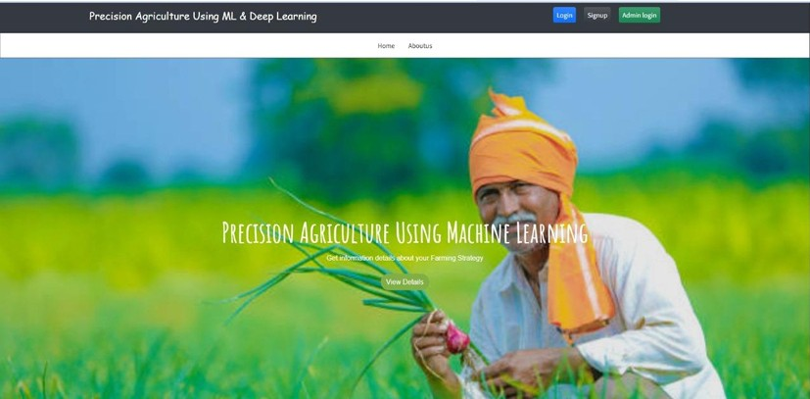
Fig. 2: GUI Homepage

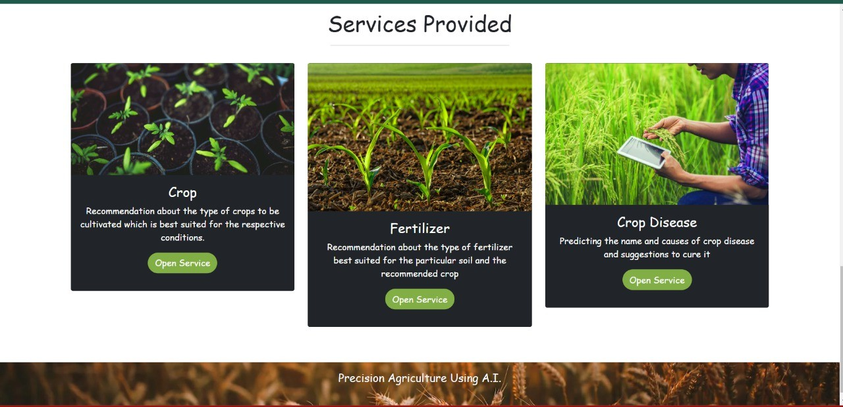
Fig. 3: Services provided

- Methodology for Crop Recommendation
The interface as shown in Figure 4 displays a selectable crop, along with a representative image of its grains. Below, the form fields let the user specify additional details such as Crop Year, Season, and agricultural inputs. Overall, this page

helps the farmer or user visualize the chosen crop and input parameters for yield prediction.
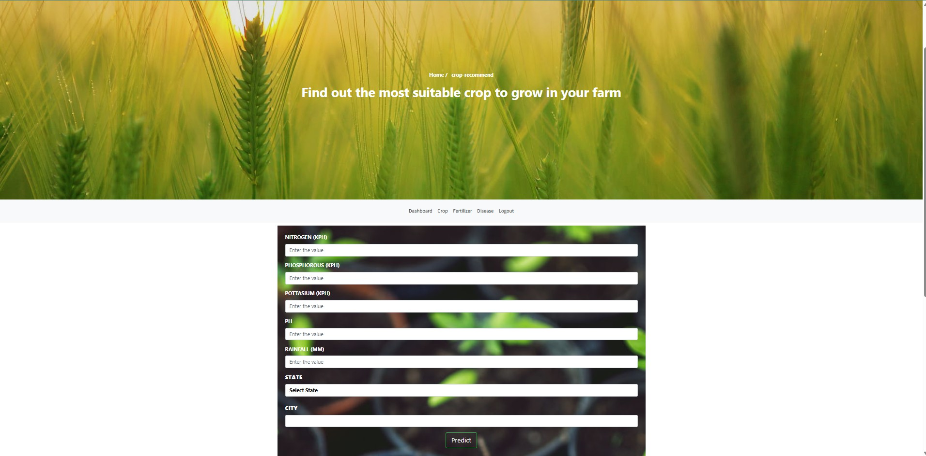
Fig. 4: Crop Recommendation page

Figure 5 below explains the workflow of an Artificial intelligence-driven crop suggestion platform.
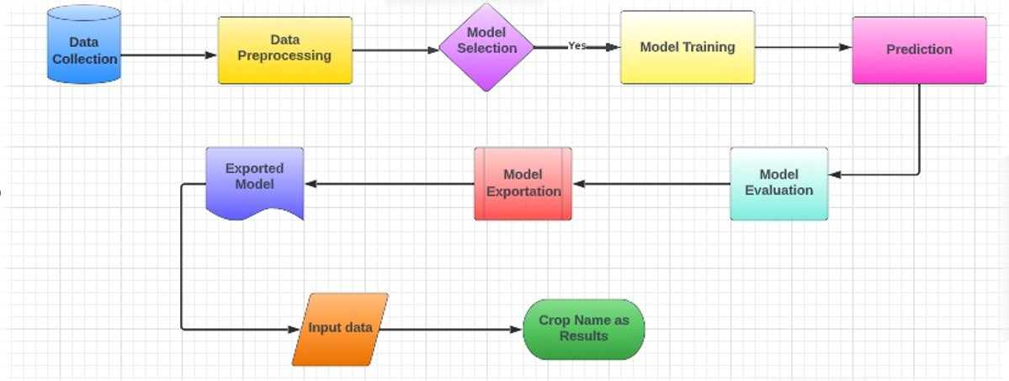
Fig. 5: System Parameters

The crop recommendation system follows these steps:
- Data Collection: Gathers essential agricultural data such as soil composition, climate parameters, and historical crop performance.
- Data Preprocessing: Cleans, normalizes, and transforms the raw data into a suitable format for machine learning.
- Model Selection: Identifies the most appropriate machine learning model for predicting suitable crops.
- Model Training: Trains the selected model using histor- ical agricultural data.
- Prediction: The trained model predicts the most suitable crop based on given input conditions.
- Model Evaluation: Assesses the performance of the trained model and fine-tunes it for better accuracy.
- Model Exportation: Saves the trained model for future use in real-time predictions.
- Exported Model: The optimized model is stored and used for processing new input data.
- Input Data: Farmers or users provide soil and weather details.
- Crop Name as Results: The system predicts and recom- mends the best crop for cultivation.

- Methodology for Fertilizer Recommendation

The second issue of Inefficient Fertilizer Usage taken care of was the fertilizer recommendation, Basically the need to use the fertilizer needed on a piece of land and based on N,P,K values (Kg / Hectare) extracted using NPK sensors or surveys conducted by the Agro based startup over the area based on statistical approach[11]. As shown in Figure 6, the farmer will be able to enter N,P,K values in kg/Ha and also choose the crop he/she wishes to grow. The model will then give recommendations based on the inputs given.

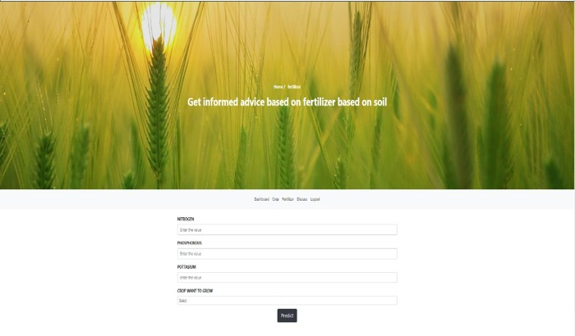
Fig. 6: Fertilizer Recommendation page

- Methodology for Disease Detection

In case of Disease Detection, ResNet-9 has been leveraged, a residual convolutional neural network architecture, instead of a traditional CNN. The following observations support the superiority of ResNet-9:
  - Faster Convergence and Stable Training: The training curves (Figure 7) illustrate the performance of various optimizers. The Adam optimizer, which was employed in training ResNet-9, achieves the lowest training cost and exhibits rapid convergence, especially when com- bined with dropout. This provides more robust learning compared to standard CNNs.

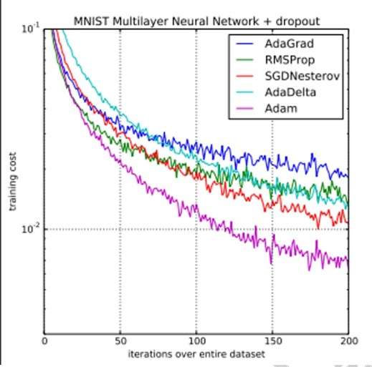

Fig. 7: Cost vs Iterations

  - Residual Learning to Prevent Degradation: Tradi- tional CNNs (Figure 8a) suffer from degradation as network depth increases. ResNet overcomes this by using skip connections (Figure 8b), allowing the model to learn residual functions as shown in equation 1:

H(x) = F (x) + x (1)

This enables better gradient flow and mitigates the van- ishing gradient problem, leading to improved accuracy and training efficiency in deeper networks like ResNet-9.

Fig. 8: Comparison of traditional CNN, ResNet architecture, and Inception-style modules. (a) Sequential CNN layers. (b) Residual block.

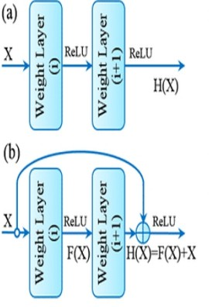
  - Enhanced Feature Propagation: As shown in Fig- ure 9c, ResNet retains and merges earlier feature maps with later ones, facilitating richer feature representations. This is particularly advantageous in detecting subtle disease patterns on crop leaves, where nuanced textures and color variations must be learned effectively.
  - Simplicity Compared to Inception Modules: Fig- ures 9d and 9e depict Inception-like architectures that utilize multi-scale convolution filters. While effective, they introduce complexity and higher computational overhead. ResNet-9, on the other hand, achieves compa- rable or superior performance with a simpler structure and fewer parameters, making it suitable for real-time and edge-based deployment.

Therefore, ResNet-9 was selected as the backbone model for the crop disease classification task due to its ability to deliver high accuracy, stable training, and computational efficiency, a choice supported by empirical studies on similar architectures [20].

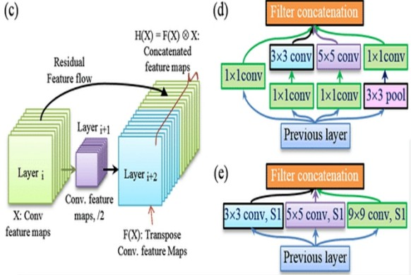

Fig. 9: Comparison of traditional CNN, ResNet architecture, and Inception-style modules. (c) Residual feature flow. (d, e) Inception-style filter concatenation. Left: training performance using various optimizers on MNIST dataset.

The ResNET Model has its ability to perform the image mapping phenomenon needed to compare the matrix vales of each section of image .Input Image in form of jpg or png of predetermined size [12]. The figure 10 below shows the farmer can upload a normal jpg/png photo and then predict the disease
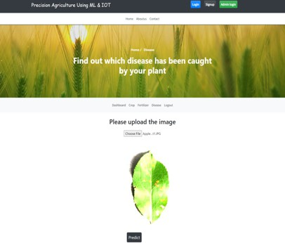
Fig. 10: Fertilizer Recommendation page

Figure 11 describes the process of crop disease detection via the means of deep learning:
    - Input Image: The system captures an image of a plant leaf using cameras or drones.
    - Base Network: A convolutional neural network (CNN) obtains feature maps from the input image, capturing texture, color, and shape patterns.
    - Feature Maps: These extracted features help identify disease-related patterns in the leaf.
    - Region Proposal Network (RPN): This module gener- ates object proposals, identifying possible diseased re- gions in the image.
    - RoI Pooling: It ensures dimensional consistency for the classifier by mapping variable-sized regions of interest to fixed-size feature maps.

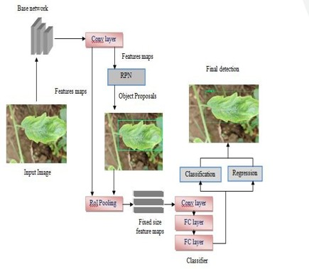
Fig. 11: Disease Detection Flowchart

    - Classifier: The extracted features are processed through fully connected (FC) layers to classify the disease type.
    - Classification and Regression:
      - Classification: The system assigns a label to the de- tected disease (e.g., bacterial spot, powdery mildew, rust, etc.).
      - Regression: The model refines the bounding box around the diseased area to improve localization accuracy.
    - Final Detection: The system provides the predicted dis- ease category along with a confidence score and bounding box highlighting the affected region.
- Results and Analysis
In this project, implementation of four widely recognized algorithms have been done—Decision Trees, Logistic Re- gression, SVM, and Random Forest. Each of these methods operates within the supervised learning paradigm.
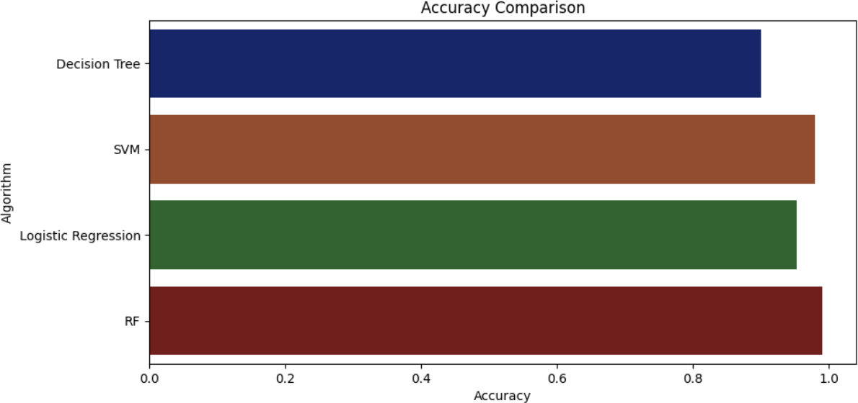
Fig. 12: Accuracy comparison

As illustrated in the accuracy comparison in 12, several machine learning algorithms were evaluated to determine the most effective model for crop recommendation. The results portray Random Forest (RF) achieved the highest accuracy when compared to SVM, Decision Tree and Logistic Regres-

sion. With a top accuracy of 97%, the RF model is evidently the most appropriate and efficient choice for this system.
The overall setup is divided into 3 modules, viz. a viz., Crop recommendation and Fertilizer recommendation,[13] and Disease detection modules, and their respective results are as follows:
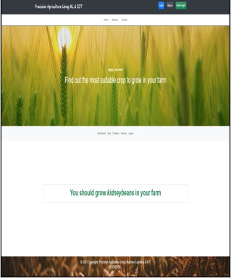
Fig. 13: Crop Recommendation Result

Figure 13 shows for a certain set of inputs the model recommends the growth of kidneybeans
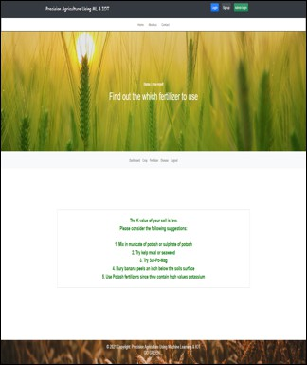
Fig. 14: Fertilizer Recommendation Result

Figure 14 shows for a certain set of inputs the model warns that the value of Potassium taken is low and suggets a few methods to rectify the issue.
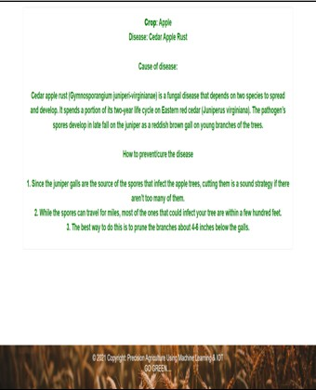
Fig. 15: Disease Detection Result
Figure 15 shows for a certain image upload, the detected crop is Apple and the Disease detected is Cedar Apple Rust, and accordingly provides information about the disease, a diagnosis and solution to cure the disease
- Challenges and Limitations
Despite the promising results, several challenges persist:
- Gathering and analyzing data is a highly demanding and time-consuming task.
- The prediction accuracy heavily relies on the robustness of the input dataset.
- Many farmers are unfamiliar with precision agriculture and machine learning, making it challenging to introduce and implement such technologies[14].
- As the amount of data increases, the complexity of processing and interpretation also grows.
- Conclusion and Future Work
All of these systems assist farmers in selecting the most suitable crops by offering valuable insights that might other- wise go unnoticed. This guidance helps reduce the risk of crop failure, boosts productivity, and protects farmers from potential financial losses. Additionally, the platform can be expanded to a web-based solution, making it accessible to millions of farmers nationwide [18].
In terms of performance, the project achieved an accuracy of 90% with Decision Trees, 94.3% with Logistic Regression, 97% with Support Vector Machine, and 99% with the Random Forest model. Looking ahead, future enhancements could involve integrating the crop recommendation module with a yield prediction subsystem, enabling farmers to estimate their expected harvest if they follow the suggested crop choices. The system also provides quantified results for disease detection, further supporting informed decision-making in agriculture.
Future research directions can work along the AI agentic frame work which can be taken into consideration in order to make automation easier via Multi Agents as well making use of Chatbots trained on knowledge of agricultural practices so that the access to knowledge at the right time and at the right way will add to the precision achievement in agriculture and focus on the random sampling[15].
Furthermore, the platform could be enhanced by incorporat- ing an IoT and machine learning-based smart irrigation system to optimize water usage [19].
Declaration of Funding
The authors declare that no funds, grants, or other fi- nancial support were received during the preparation of this manuscript.
Declaration of Competing Interests
The authors declare that they have no known competing financial interests, non-financial interests or personal relation- ships that could have appeared to influence the work reported in this paper.

Data Availability
The Crop Recommendation datasets that support the findings of this study are openly available in Kaggle at https://www.kaggle.com/datasets/atharvaingle/ crop-recommendation-dataset.
References
- Fahad Kamraan Syed, Agniswar Paul, Ajay Kumar, Jaideep Cherukuri, ”Low-cost IoT+ML design for smart farming with multiple applica- tions,” 10th International Conference on Computing, Communication and Networking Technologies, 2019.
- Archana Gupta, Dharmil Nagda, Pratiksha Nikhare, Atharva Sandbhor, ”Smart Management of Crop Cultivation using IoT and Machine Learn- ing,” IEEE, 2019.
- Radhika, Narendiran, ”Kind of Crops and Small Plants Prediction using IoT with Machine Learning,” International Journal of Computer & Mathematical Sciences, 2018.
- Anguraj.Ka, Thiyaneswaran.Bb, Megashree.Gc, Preetha Shri.J.Gd, Navya.Se, Jayanthi. Jf, ”Crop Recommendation on Analyzing Soil Using Machine Learning,” 2020.
- A. Mythili, ”Classification of Soil and Crop Suggestion using Machine Learning Techniques,” IEEE, 2019.
- P. Mehta, H. Shah, V. Kori, V. Vikani, S. Shukla, M. Shenoy, ”Survey of unsupervised machine learning algorithms on precision agricultural data,” IEEE, 2018.
- Rani Holambe, Pooja Patil, Padmaja Pawar, Saurabh Salunkhe, Hrushikesh Joshi, ”IoT-based Crop Recommendation, Crop Disease Prediction, and Its Solution,” IRJET, 2019.
- V. Balafas, E. Karantoumanis, M. Louta, N. Ploskas, ”Machine Learning and Deep Learning for Plant Disease Classification and Detection,” IEEE Access, vol. 11, pp. 114352-114362, Oct. 2023. doi: 10.1109/AC- CESS.2023.3324722.
- K. Z. Hasan, L. Mou, and X. X. Zhu, “Drone-based remote sensing for precision agriculture using convolutional neural networks,” in 2020 IEEE Int. Geosci. Remote Sens. Symp. (IGARSS), Waikoloa, HI, USA, 2020, pp. 7170–7173.
- M. S. Badar, A.ElSaddik, and A. Badarneh, “Machine learning for soil moisture estimation using multi-sensor data in precision agriculture,” IEEE Access, vol. 10, pp. 12355–12366, 2022.
- M. Ayaz, M. Ammad-uddin, Z. Sharif, A. Mansour and E. M. Aggoune, “Internet-of-Things (IoT)-based smart agriculture: Toward making the fields talk,” IEEE Access, vol. 7, pp. 129551–129583, 2019, doi: 10.1109/ACCESS.2019.2932609.
- X. Song, Y. Zhang, H. Guo and W. Zhou, “A comprehensive review of trends, applications and challenges in smart agriculture,” IEEE Internet of Things Journal, vol. 8, no. 22, pp. 16484–16500, Nov. 2021, doi: 10.1109/JIOT.2021.3056751.
- J. Sheng, C. Li, F. Zhou, L. Tong and M. Ahmed, “An improved YOLO- based pest detection algorithm for precision agriculture,” IEEE Access, vol. 10, pp. 64801–64811, 2022, doi: 10.1109/ACCESS.2022.3184455.
- T. Kalampokas, C. Gravalos, P. Tsirigotis, S. Tarapoulouzi and
  - Stamelos, “Machine learning-based approach for autonomous spray- ing in vineyards,” in 2022 30th Mediterranean Conference on Con- trol and Automation (MED), Athens, Greece, 2022, pp. 1–6, doi: 10.1109/MED54522.2022.9837263.
- S. Anugu, A. Kumar, D. Mandla, K. K. Ragireddy and V. Koutha, “A deep learning framework for crop yield prediction using re- mote sensing data,” in 2022 IEEE Int. Geosci. Remote Sens. Symp. (IGARSS), Kuala Lumpur, Malaysia, 2022, pp. 2868–2871, doi: 10.1109/IGARSS46834.2022.9884288.
- Nishith S Shetty, Naman N Karanth and Vinay V Hegde, ”Enhancing Crop Productivity: Integrated Solutions for Crop Yield, Crop Rec- ommendation, and Crop Disease Management,” 2023 7th Interna- tional Conference on Computation System and Information Technol- ogy for Sustainable Solutions (CSITSS), Bangalore, India, 2023, doi: 10.1109/CSITSS60515.2023.10334167
- CS Arvind, Aditi Totla, Tanisha Jain, Nandini Sinha and R Jyothi, “Deep Learning Based Plant Disease Classification With Explainable AI and Mitigation Recommendation,” in 2021 IEEE Symposium Series on Computational Intelligence (SSCI), Orlando, FL, USA, 2022, doi: 10.1109/SSCI50451.2021.9659869.
- B Varshitha, Ananya G, Vanishree K and Nagaraja G S, “Farmeasy
- A Web Portal for Farmers,” in 2023 7th International Conference on Computation System and Information Technology for Sustainable Solutions (CSITSS), Bangalore, India, 2023, doi: 10.1109/CSITSS60515.2023.10334226
- Veena Divya Krishnappa , R. H. Aswathy, and P. Suresh, “Efficient IoT
-Machine Learning Based Smart Irrigation Using Support Tree Algae Algorithm,” in 2024 Taylor & Francis Online, Bangalore, India, 2024 ,
pp. 6775–6790, doi: https://doi.org/10.1080/03772063.2024.2319707.
- Abhishek R, Aditya S, S Prajwall Narayana and Suma B, “An Em- pirical Study of ResNet50 Hyperparameter Tuning for Plant Disease Classification,” in 2024 8th International Conference on Computational System and Information Technology for Sustainable Solutions (CSITSS), Bangalore, India, 2025, doi: 10.1109/CSITSS64042.2024.10816835.

